**A Project Report on**

**Restaurant Management System**

Submission of

**Course CSE-200: Software Development Project-II**

By

**Md. Montasir Amin** **Mostafa Ahmed An-Nur**

**Roll: 17102033** **Roll: 17102024**

**Submission Date: February 28, 2019**



Department of Computer Science & Engineering

**Jatiya Kabi Kazi Nazrul Islam University**

**Supervised By :**

**Kazi Mahmudul Hassan**

Lecturer,

Dept. of CSE, Jatiya Kabi Kazi Nazrul Islam University.

The undersigned have examined the report entitled “**Restaurant Management System**” presented by **Md. Montasir Amin**, a member of course **CSE-200: Software Development Project-II** group and hereby certify that it is worthy of acceptance.

28-02-2019 **Kazi Mahmudul Hassan**

Date Advisor’s name

28-02-2019 **Mostafa Ahmed An-Nur**

Date Group member name

Dedication

Dedicated to: **Our Honorable Teachers.**

# ABSTRACT

## **Restaurant Management system** is indispensable while executing a Restaurant. Earlier, it was very woeful task to maintain a Restaurant before Software augmantion.But now, most of the Restaurants are going on with a Software named Restaurant Management System. In our project we have fixed our action on calculating the different types of Food items and drinks with their rate and amount including TAX and Delivery Cost.We also put a system to calculate the bconversion of currency from BDT to other Currency.Together this, we also developed a simple Calculator and developed a system to calculate the Admin’s debit-credit calculation,basically the Total Profit.It is noted that, we also implemented the fascility of a Printer so that, We can easily print out the customers receipt slip(Cash Memo) and also the Admin’s Profit Receipt slip including the updated time and date there in The software project also have the fascility of username and Password so that anybody out of authority can’t access the Software. After neglecting all invalid or illegal data input and taking relevant information from customer it outputs us a customer’s total bill that he has to pay and also the Debit-Credit calculation of the Restaurant itself.. “Restaurant Management System” is the project that helps us for calculating a customer’s total bill and also Restaurants own Profit along with Printable fascility. It is noted that, we have developed our software project by Java Language and Netbeans IDE.

**Advantages of this software are as below:**

* Contain the opportunity of Password Protection
* Someone can easily calculate Customers total bill in a Restaurant.
* Someone can easily calculate Total profit of a Restaurant.
* Have the facility to print out the Customer’s bill receipt and also print the Restaurant’s own profit when clicked.
* Eliminates the limitations of manual calculations.
* Have Features of Data Validation
* The software provides the customer and the authority the instant time while Printing out the Receipt slip.
* Features of small **General Calculator** and **Currency Convertor** Panel help the authority in certain sector.
* The software takes the current date automatically.
* Authority can handle more than one customer’s bill calculations in a single start up of the software.

# ACKNOWLEDGMENTS

First and foremost, I would like to express my gratitude to Allah, the most gracious and the most merciful, for allowing me to complete this work. And then I would like to thank to my **Supervisor KAZI MAHMUDUL HASSAN,** lecturer, Department of Computer Science & Engineering, Jatiya Kabi Kazi Nazrul Islam University, Trishal, Mymensingh for his helpful suggestions in selecting my project topic, planning and implementing the work. Also he greatly helped me in improving my report writing and presentations, which, obviously, will guide me throughout my future life. I would like to give my special thanks to my parents and friends.

We wish to express thanks to **Engineer A.H.M Kamal**, Head, Department of Computer Science & Engineering, Jatiya Kabi Kazi Nazrul Islam University for providing us lab opportunities with lab materials related to our project work.

We also thank all of our friends, group member & lab assistant and our family for helping to complete the project **“Restaurant Management System”**.

Finally, we express our thanks to the Department of Computer Science and Engineering for giving us the opportunity to study here and supporting us greatly through our graduate study.

Table of Contents

Abstract iv

Acknowledgements v

Table of Contents vi

List of Figures vii

**CHAPTER 01: INTRODUCTION** 09

1.1 Introduction 10

1.2 Background Study 10

1.3 Our Approach 13

1.4 Objectives 11

1.5 Key Features of Proposed System 12

1.6 Key words of Proposed System 12

1.7 Organization of This Report 13

**CHAPTER 02: Software Overview** 14

2.1 Motivation 14

2.2 Tools 14

2.3 Overview Of The Software 16

**CHAPTER 03: Restaurant Management System** 17

3.1 Pictorial Description 17

**CHAPTER 04: Program Analysis and Design** 19

4.1 Flowchart 19

4.2 How it works 20

4.3 Data validation 20

**CHAPTER 05: RESULT AND DISCUSSION** 21

5.1 Limitations 21

5.2 Further Development(future work) 21

5.3 Result & Discussion 23

# LIST OF FIGURES

Figure 1: A typical Restaurant. 9

Figure 2(a): Typical logo of a Restaurant. 10

Figure 2(b): Typical logo of a Restaurant. 10

Figure 3: Restaurant Management System 11

Figure 4: NetBeans IDE. 14

Figure 5: JAVA language theme 15

Figure 6: JAVA language symbol 15

Figure 7: JAVA Programming language 15

Figure 8: screenshot1 17

Figure 9: screenshot2 17

Figure 10: screenshot3 17

Figure 11: screenshot4 17

Figure 12: screenshot5 17

Figure 13: screenshot6 17

Figure 14: screenshot7 18

Figure 15: screenshot8 18

Figure 16: screenshot9 18

Figure 17: **Flowchart of the Project** 19

Figure 18: **Data Validation whether its correct or wrong** 20

Figure 19: WEB Connectivity Icon 21

Figure 20: Storage Icon 21

Figure 21(a):Nutrition Analysis 22

Figure 21(b):Nutrition Analysis 22

Figure 20: Data Storage 22

Figure 23: Symbol for Web Connectivity 22

# CHAPTER01: INTRODUCTION

# 1.1 Introduction:

A restaurant management system is POS software designed for the foodservice industry. Like a standard POS system, restaurant management system helps us capture transactions and manage inventory with accuracy and generally run everyday processes more efficiently. A setup may include both software and hardware, too, like the cash register, barcode scanner, and receipt printer.

**Restaurant management software** is the collective term for [software](https://en.wikipedia.org/wiki/Software) that is used to aid in [restaurant](https://en.wikipedia.org/wiki/Restaurant) operations. This is mainly [POS software](https://en.wikipedia.org/wiki/Point_of_sale), but can include other types of software as well. Such software usually assists with ordering, billing, [inventory](https://en.wikipedia.org/wiki/Inventory) management, and queue management, and can be broadly divided into FOH (front of house) and BOH (back of house) software. Benefits of using software to manage aspects of restaurant operations include efficiency and a reduction in customer wait times, as well as preventing employee scams.

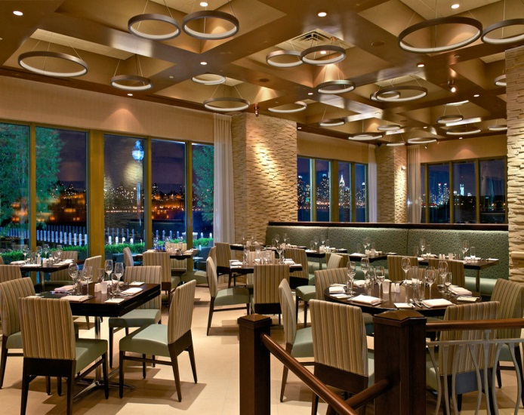

FIG 1: A typical Restaurant.

# 1.2 Background Study:

Before developing a software like Restaurant Management System, We have to study a little about what is management system in Restaurant sector and the related term in this. Restaurant management system software is the software by which we can easily calculate the total bill along with VAT and delivery charge of a customer. We can also Generate the receipt of bill automatically and further can print out the bill receipt by the help of a printer device. This facility can also be applied in calculating total salary of waiters and others cost in order to get the point whether in a specific month a restaurant has achieved its Big-profit or Loss.



FIG 2(a): Typical Logo of a Restaurant FIG 2(b): Typical Logo of a Restaurant

# 1.3 Our Approach:

First, we studied about the facility behind Restaurant management system compare to manually handling this problem. Then we have decided that, this project can overcome all the limitations of the manually existing system. The system provides proper security and reduces the manual work. The system is very simple in design and to implement. The system requires very low system resources and the system will work in almost all configurations.

# 1.4 Objectives:

Manually it is very difficult to handle Restaurant Management System manually in individual customer’s relevant information and total cost of the customer counting the total bill along with VAT and delivery charge if necessary. With the help of computer it becomes easy and faster to manage the system. In this project, it is the facilities to take all information and calculate a customer’s total bill calculation in the system. The main objective of the system is which target to put a security to the user of the software and calculate his total bill of food purchasing and also automatically generating a receipt and printing out feature of this along with calculating Restaurants owners monthly Evaluation whether he is in Loss or in Big-profit environment. The extra feature here exists are aided general calculator, currency conversion calculator, automatic date and time feature in the receipt paper and other related things.

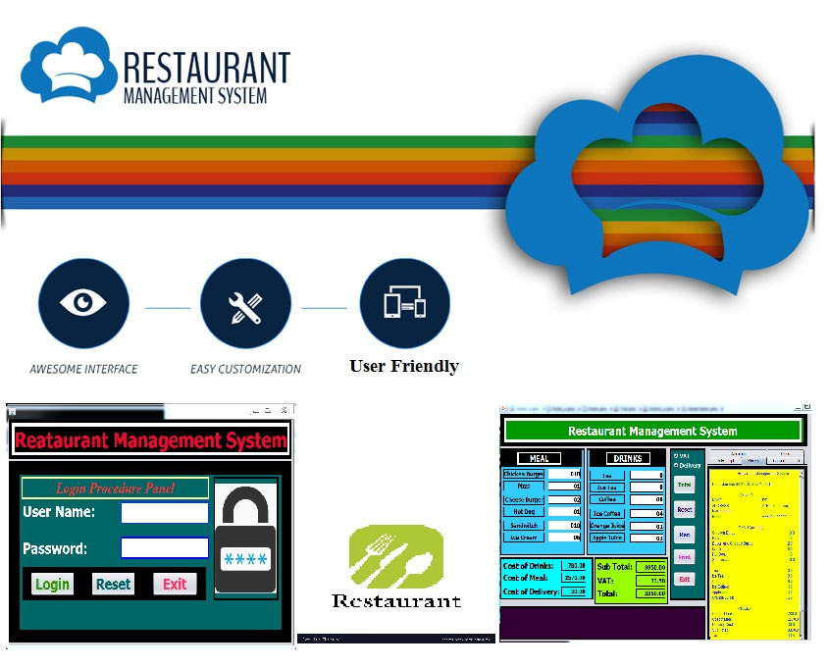

## FIG 3: Restaurant Management System.

# 1.5 Key Features of Proposed System:

**The project will have the following key features:**

* Username and password facility.
* Calculate Customers total bill
* Generates Bill Receipt
* Print out Bill Receipt
* Calculate and Print out Authority’s (Restaurant Owner) total Profit.
* Automatic date input feature in Bill Receipt
* Excellent data validation.
* Can calculate more than one customers Bill in a single start-up.
* Aided General Calculator
* Aided Currency conversion calculator

# 1.6 Keywords:

**The keywords related to our projects are as follow:**

* User Name
* Password(Log In)
* Name and Address of the Customer
* Cost of Meal and Drinks
* Delivery Cost
* TAX
* Data Validation
* Total Bill of Customer
* Reset all items
* Print Customers Bill Receipt
* Small General Calculator
* Currency Converter
* Admins Debit-Credit Calculation
* Printable Cash Memo
* Printable Authorities Debit-Credit Calculation and Profit
* Time and Date
* Resetting all items for further use.

# 1.7 Organization of This Report:

This report is organized in five chapters. The introductory information of the project work have already discussed in this chapter.

**Chapter 1: Introduction**

In this part we have introduced what our project is and how it can help a person to calculate a customer’s Bill, generates Bill Receipt and Print out it also achieving the evaluation of the restaurant's owner whether in a specific month if he had achieved hoe much profit thereby .We have also described about what features and facilities in our proposed system will have.

**Chapter 2: Software Overview**

The Restaurant Management System is the project which is mainly developed for calculating a customer’s total Bill, generating his/her Bill receipt and print out this. It also shows the running time in the bill receipt automatically. The other facility is that it decides after various calculation whether the owner of the Restaurants have achieved Big-profit or Loss in that environment.

**Chapter 3: Restaurant Management System**

In this section the traditional and conventional ways of software development is described briefly .We also described which development process we followed during the development of this proposed system. The system architecture and model is also included textually and visually. We described the software model through necessary Screenshots in this chapter. Basically, Pictorial description of software project is given in this section.

**Chapter 4: Program Analysis and Design**

We discussed about the specific steps which are taken to develop the proposed system. We represented our software project with Flow chart and state diagram in this chapter. We also explained here about how it works and data validation.

**Chapter 5: Result and Discussion.**

In this section we have discussed and shown the final output of our Software Development Project. We also described about the testing part, scope and limitation, further development.

# CHAPTER 02: Software Overview

# 2.1 Motivation:

After realizing the theme of taking orders from the customers and calculating them with other circumstances after security access in order to get a fluent concept of total bill of the customer, generating the Bill receipt and also print out this. The other major facility is to machinery decision of whether the Owner of the Customer has achieved great-profit or loss.

# 2.2 Tools:

# We used an IDE named NetBeans v 8.2 to implement, build and operate the code.



FIG 4: NetBeans IDE.

**(2)We took the help of JAVA language to build our software project.**

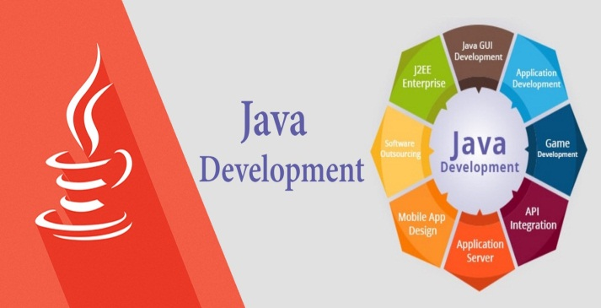 

FIG 5: JAVA language theme FIG 6: JAVA language Symbol

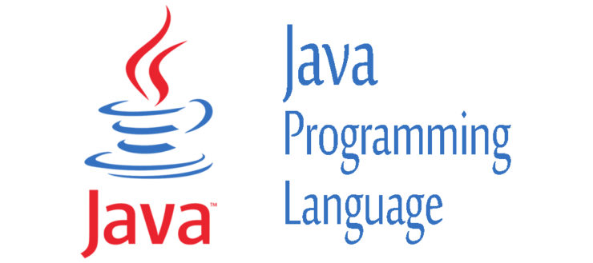

FIG 7: JAVA Programming Language

## 

### 

### 

### Basically we took the help of JAVA SWING here.

# 2.3 Overview of the Software:

The software we developed here is simple to use. Whenever the authority needs to calculate the customer’s total bill after order they just have to click the software icon. Then the software will ask them the required username and password. If the authority is legal they will enter the correct username and password and can get access to the main function of the software. The software then asks them the amount of each food and drink item. There are options for VAT and also delivery. If clicked delivery button it asks for customers Name, Address and Contact number. After taking all data this program calculates them and shows the total Bill of the customer and when clicking Receipt Button it automatically generates a Bill receipt in a nice formation pattern including current date and time. Finally we get the exact cost that the customer has to pay in the printed Bill Receipt.

Another thing is in Office panel, we can calculate if the owners of the Restaurants have achieved Big-profit or Loss with the print out facility also.

The additional feature of this project is Aided general Calculator, Aided Currency Conversion Calculator and so on.

# CHAPTER 03: Restaurant Management System.

# 3.1 Pictorial Description:

# Our Software project related all necessary screenshots are provided below:

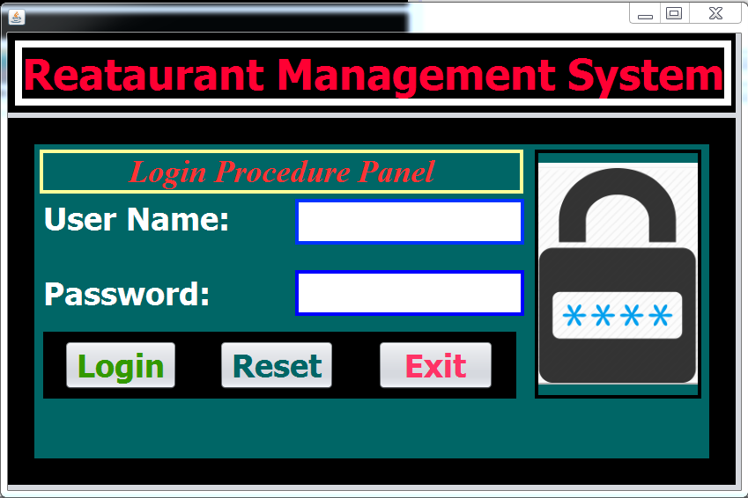 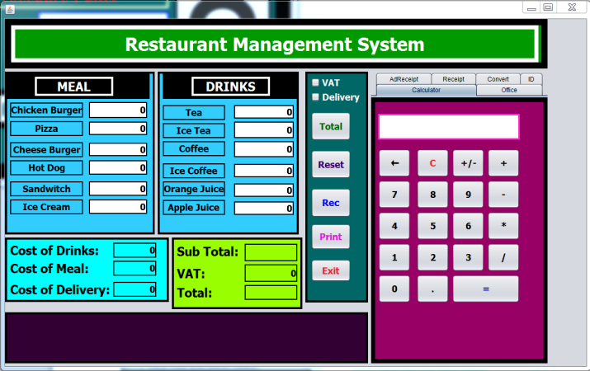

**FIG 8: screenshot1** **FIG 9: screenshot2**

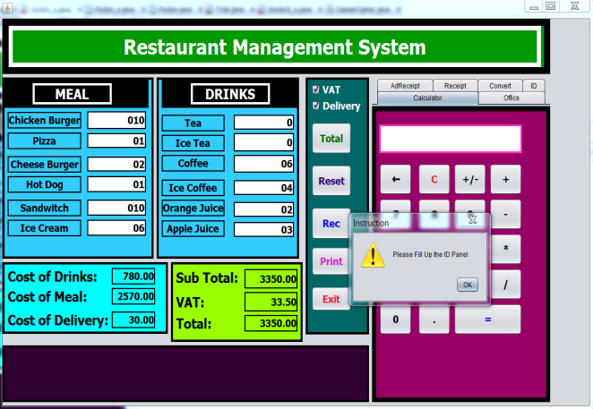 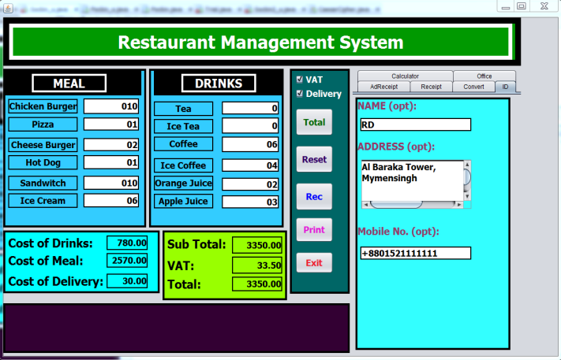

**FIG 10: screenshot3**  **FIG 11: screenshot4**

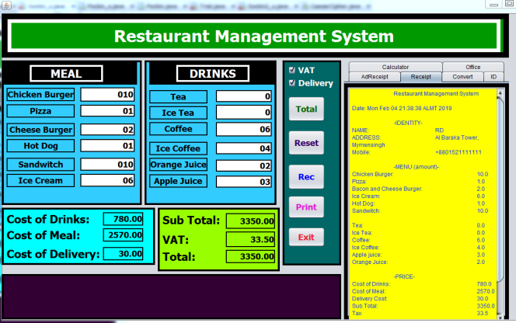 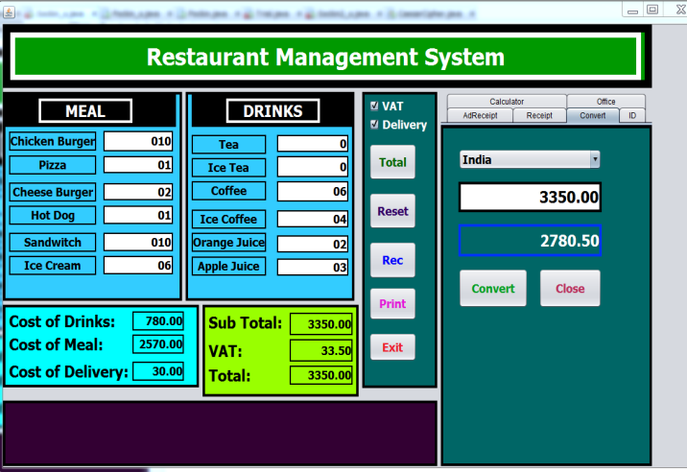

**FIG 12: screenshot5**  **FIG 13: screenshot6**

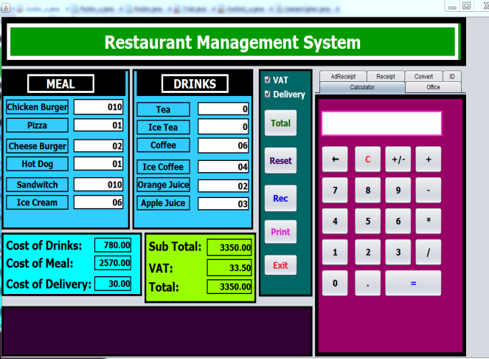 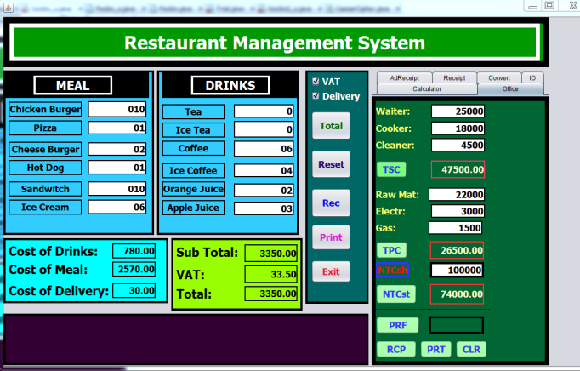

**FIG 14: screenshot7** **FIG 15: screenshot8**

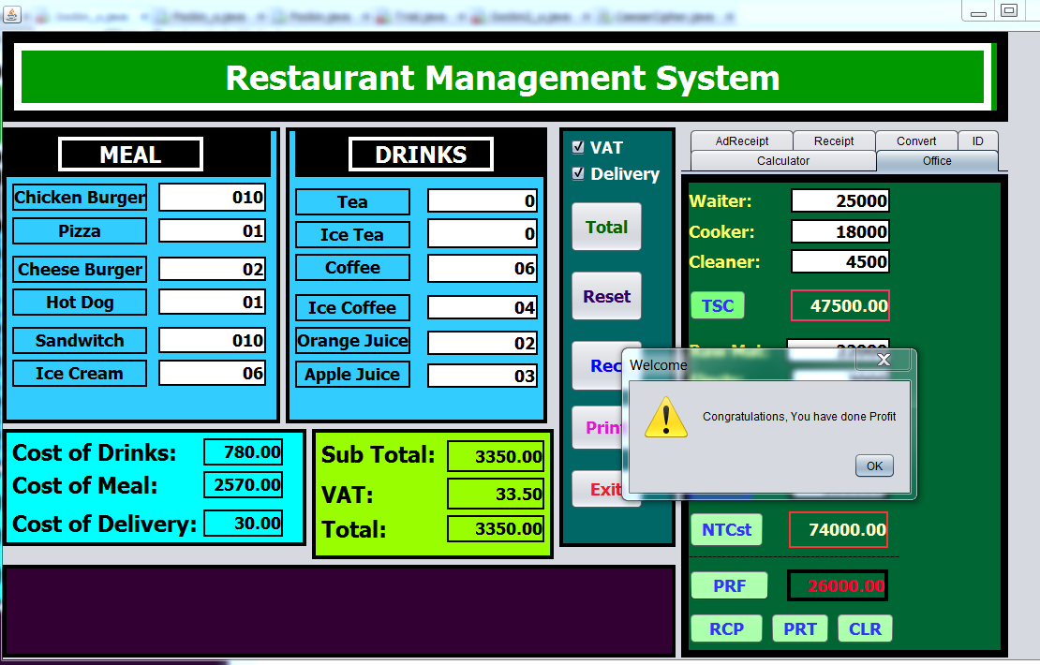

**FIG 16: screenshot9**

# CHAPTER 04: Program Analysis and Design

# 4.1 Flowchart:

**Figure 17: Flowchart of the Project** **(Restaurant Management System)**

# 4.2 How It Works:

The project is simple to use. It was developed by JAVA language. We took the help of Swing which is mainly a **GUI**widget toolkit. With the help of JAVA’s built in function the software is developed. After accessing the grant permission the software asks for the necessary information for processing and calculating the total bill of the customer, generates bill receipt, print out the receipt.

Similarly after taking the total salary amount of the waiters, cookers, cleaners; total costs of electricity, gas and raw materials and also considering the total amount of Cash in hand it decides total profit of the owner.

The extra feature is aided general calculator, aided currency conversion calculator and so on.

# 4.4 Data Validation:

The software project also has the feature of data validation. That means whenever you enter any illegal data specially type mistakes it denies to access these data and sound beep for entering the correct information until it receives the legal data.

Data validation mainly appears whenever we mistakenly enters unauthorized data value like number value in the sector of alphabetical value and alphabetical value in the sector of number value and so on.



FIG 18 : Data validation whether its correct or wrong.

**CHAPTER 05: RESULT AND DISCUSSION**

# 5.1 Limitations:

Though the project helps us calculating total bill, processing receipt and print out them and saves our time it has some limitations which are described below:

(1)This software is unable to web connectivity so that it has the lacking whenever a restaurant has different branch in different place.

(2) This software is unable to store a customer’s information in a file for future query.

(3)The software is not build up as web connected so that someone can keep web contact through the software.

Though this system has many functionalities it will takes more time to develop at all.

 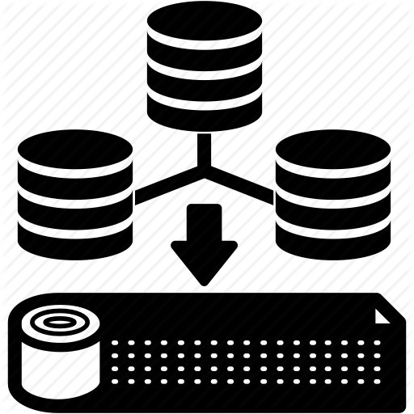

FIG 19: WEB connectivity Icon FIG 20: Storage Icon

# 5.2 Further Development (future work):

Our system has all the functionalities to manage a Restaurant Management process. But we have some plan to make it more efficient, reliable.

Our expectation is that in future we can make sure to add some important features i.e.:

(1) Nutritional Analysis aided interface in this software so that authority can easily get the nutritional information of their food item easily.

(2) Also, we expect to add the facility for storing customer’s data and information in a file for the purpose of later query.

(3) We also expect to add a web base interface in this software project so that different branch of a Restaurant can directly connect to the each other through Web by the help of this software project and can share each one’s updation in a specific moment.

(4) A feature of data analytic.

 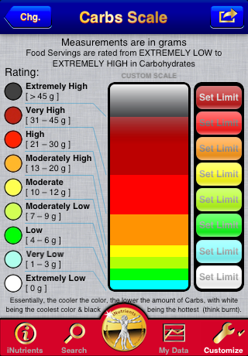

FIG 21(a) : Nutrition Analysis FIG 21(b) : Nutrition Analysis

 

FIG 22: Data Storage FIG 23: Symbol for Web Connectivity

# 5.3 Result & Discussions:

We tried to develop the efficient and advance software for calculating the Bill of a customer, generating its receipt, printing out the receipt and also calculating the Restaurant owner’s profit-loss(included personnel salary, neat total cost etc. ) of a customer. Our system can successfully do calculations and data validations for the customer and also for the authority (owner). It has a very simplified and easy to use user interface. It is a GUI application and designed to support computer devices, it has different layout for devices having different screen sizes. It is kept secure with a username and default password. It has a nice and ordered architectural formation with structure and colour. It’s easily understandable and executable as we have implemented **toolTip text** at every point of the overall software. It can save enormous amount of time and energy of the necessary calculations and generation instead of providing manual receipt. Also, manual calculations are error prone which can be a great problem, but this system ensures error free, validation featured calculations. Reports can be generated in seconds and invoice is created dynamically. Besides the existing features and functionalities, it will be more advanced as we have lots of features planned for further development.